

Business Requirement Definition:

**Security Transport Application**

Foskor ICT

Acid Division

Date: 12th October 2020

Version: 1.1

# Document Control

|  |  |  |  |
| --- | --- | --- | --- |
| Role | Name | Date | Version |
| Author | Yolisa Nogantshi | 14/10/2020 | 1.1 |
| Author | Mpho Cele | 14/10/2020 | 1.1 |
| Approver | Nomsa Sibeko | 14/10/2020 | 1.1 |

Contents

Document Control 2

INTRODUCTION 4

Overview 4

Responsibilities 4

High Level “As Is” Business Processes 5

Gaps 7

Recommendations 8

High Level “To Be” Business Processes 9

Specifications 11

Software Tools 11

Programming languages: 11

Development Environments: 11

Database Schema 11

# INTRODUCTION

This document provides a formal statement of the business process requirements for the Security Transport Application and forms part of the Definition phase of the project.

The document details the “As Is” and “To Be” process requirements, identified gaps and recommendations.

<explain transport request background>

# Overview

The Definition phase activity consists of obtaining the system functionality requirements from the users of the current application.

# Responsibilities

|  |  |  |
| --- | --- | --- |
| Role | Name | Title |
| Foskor Process Owner | Shawn van Rensburg | Security Site Manager |
| Foskor Process Operators | Simphiwe Mthethwa | Visitors Reception Clerk |

# High Level “As Is” Business Processes

The transport request process is initiated by a manual process where a user has a need to be transported to a certain destination <expand – form located on intranet details>.

Certain steps are processed in Microsoft Access (2010) and Microsoft Excel (2016) to facilitate invoicing.

1. A Foskor user (e.g. Supervisor) completes the “Request for Transport” form and takes the form to the Security Controller. <The first section…> <include reasons why they complete first part – reasons for transport etc>
2. The Security Controller completes the “Security Control Room use” section of the “Request for Transport” form and hands it to one of the drivers on shift to complete the “Security Driver” section of the form <investigate OB fields>
3. The Driver completes the “Security Driver use” section of the form well as the “in” section of the “Vehicle Register” document. <This includes the first kilometer reading of the vehicle before the trip, the destination…>
4. The Driver transports the passenger(s) to or from the specified destination and returns to Foskor <Gap – sub trip handling – ask Shawn how to proceed>
5. The Driver completes details about trip after transporting the passenger(s) and returns the form to the Data Capturer
6. The Data Capturer captures the data into the form on their Transport system, which is on the Microsoft Access 2010. Some details cannot be captured accurately due to limitations on the current application. <be specific which details>
7. The KSS Supervisor reviews the information in the Transport system Access table and exports the data to Excel for editing
8. The KSS Supervisor sends a report for invoicing to KSS and Foskor Finance

The diagram below is to illustrate how the process currently flows:

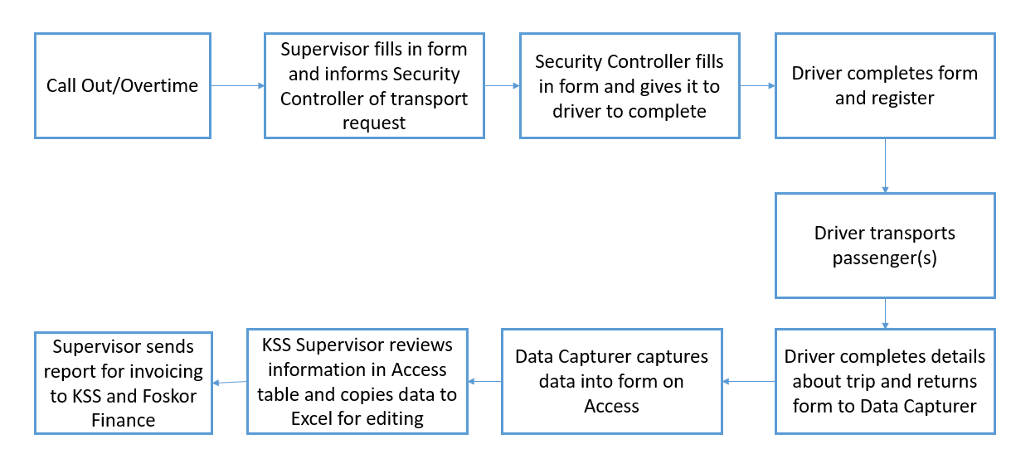

Figure 1: High Level "As Is" Process Flow Diagram

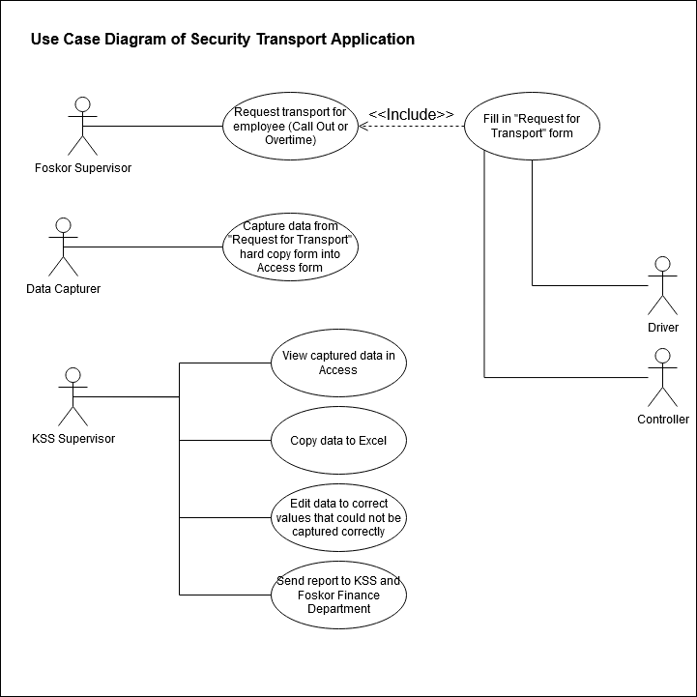

Figure : Use Case Diagram of Process Flow

## Gaps

1. The data capturer is unable to add or remove entries in the Reason for Transport, Driver, Destination, and Vehicle Make tables. This creates the need for the KSS supervisor to copy the records from Access to Excel, in order to properly capture the details of each trip.
2. The software platform, Microsoft Access 2010, is outdated. Newer versions of Access cannot open the database, and the details of how to edit the database objects have not been properly documented. It is therefore impractical to continue using the same software.
3. The security mechanisms used by the current database are unknown. This makes it difficult for both users and developers to work with the program in the intended manner and to make changes when necessary.
4. <>

## Recommendations

1. Give the data capturer the ability to add or remove entries in the Reason for Transport, Driver, Destination, and Vehicle Make tables. This should eliminate or reduce the need for the KSS supervisor to edit the records for the report.
2. Create the form and reporting functions in a desktop application. The desktop application should integrate with Microsoft SQL. This will make it standardised with existing Foskor databases and easier to manage.
3. Give the different users roles so that the data is securely available to those who are required to work with it

# High Level “To Be” Business Processes

* Security Admin: The security will have add, delete, edit, update button on the system so that she can be able to make some changes.

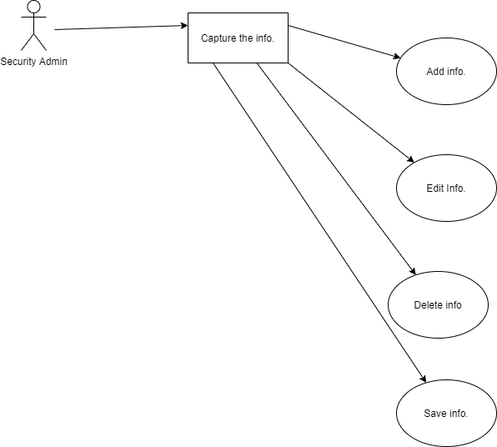

* Security Supervisor: View the report Edit the report Print the report Email the report to finance

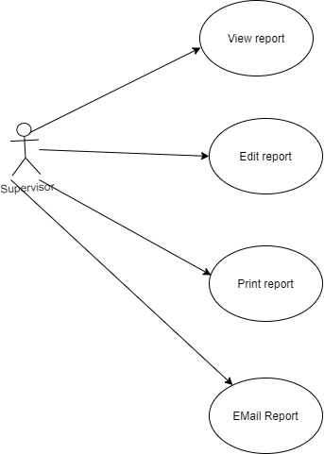

# Specifications

## Software Tools

### Programming languages:

* Java
* SQL

### Development Environments:

* Eclipse IDE for Java Developers
* Microsoft SQL Server 2014

## Database Schema

To be discussed